**Refresh using Expdp and IMPDP**

**Before Automation**

1. Login to the requested database and will create a directory manually by using the below command

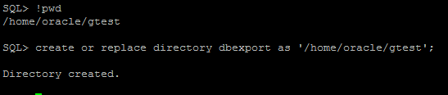

1. Will prepare a par file for export and import manually by mentioned below,

**Export Script**

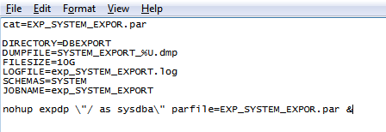

**Import Script**

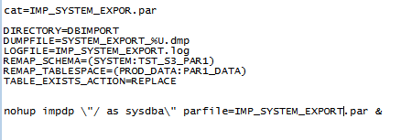

1. Execute the script manually for export and import

**Taking export of source schema**

1. Give input for dumpfiles,DB name and schema name as mentioned below,

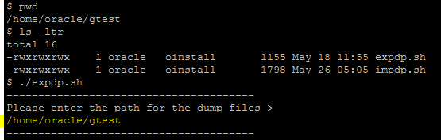

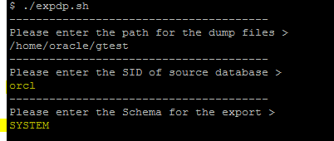

1. Script will create the directory automatically and create a shell script for export.

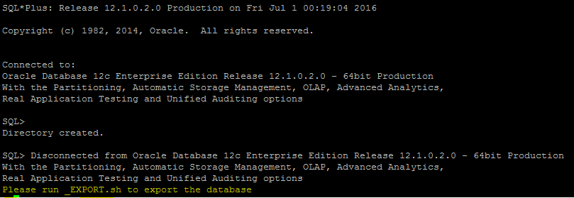

1. Execute the below shell script to start the export

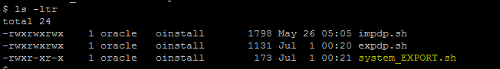



**For importing schema into target database**

1. Execute the impdp script and give all the input as mentioned below,

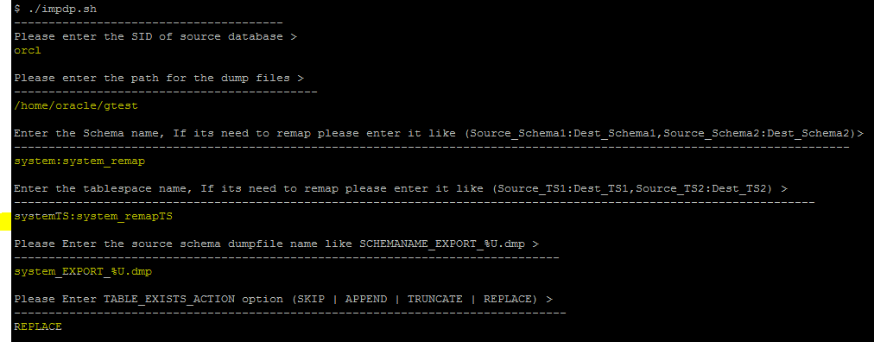

1. Based on the input dumps and directory, oracle will create generate a script

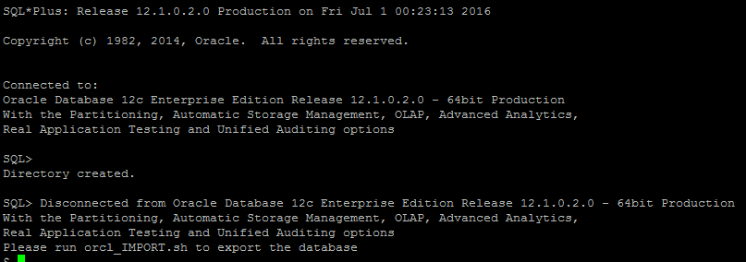

1. Execute the below shell script to start import.

